Computer Language Coding Concepts

Specialization & Data Replacement
You do not need any specialization techniques to alter the behavior of a base object.

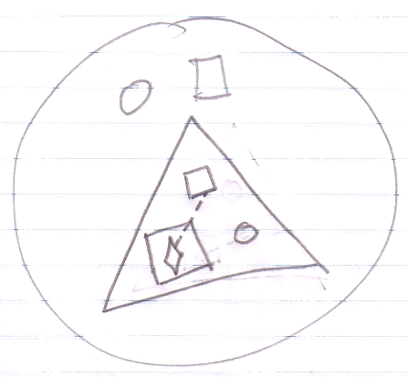

Anything inside the base object is just data, that can be changed, including the commands, command calls and member sets. This is all just data that you can change.

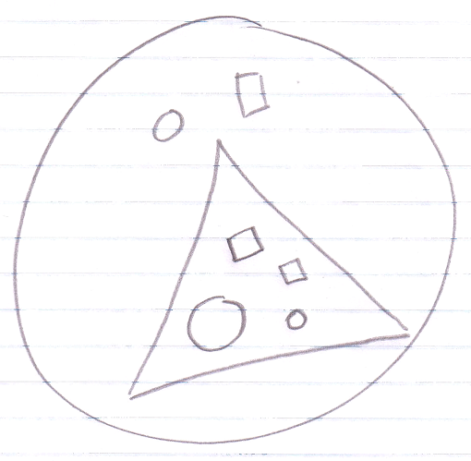

One condition though is that the data is accessible.

However, data replacement is not what we usually call specialization. What we call specialization are less destructive methods where most of the data stays in tact.

Some specialization techniques actually replace data, rather than just add it, but they are generally considered less destructive than sheer data replacement. Data replacement and specialization are two different concepts.

Author & Copyright: Jan-Joost van Zon Date: May 19, 2010 – July 12, 2010 Location: Oosterhout, The Netherlands Status: Finished

